Don’t Leave Learning Up to Chance: Framing and Reflection
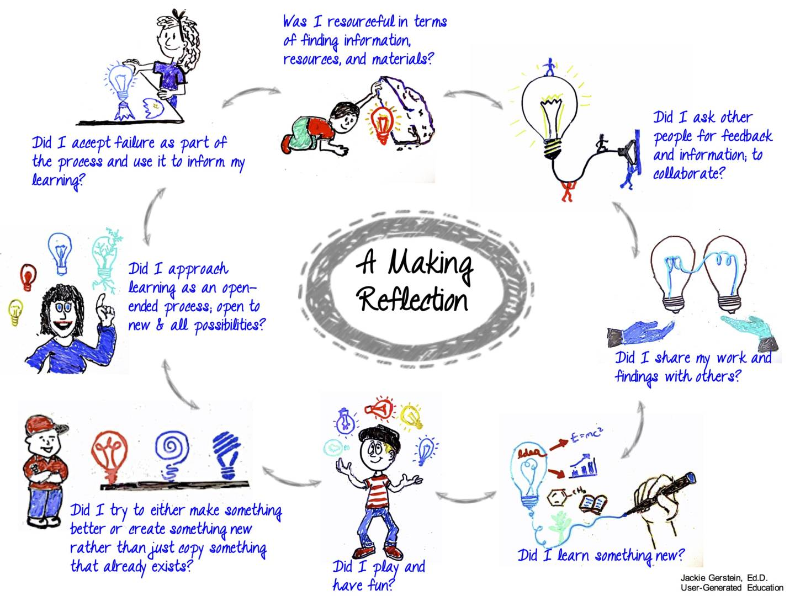
Infographic explaining the importance of reflection in maker education. (Courtesy Jackie Gerstein/
